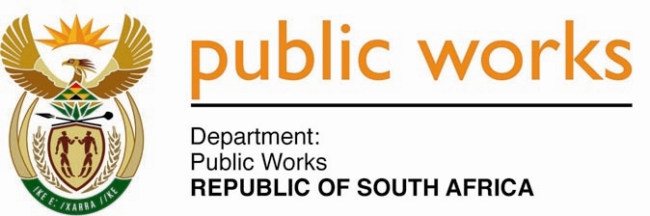

**MINISTRY**

**PUBLIC WORKS AND INFRASTRUCTURE**

**REPUBLIC OF SOUTH AFRICA**

Department of Public Works l Central Government Offices l 256 Madiba Street l Pretoria l Contact: +27 (0)12 406 1627 l Fax: +27 (0)12 323 7573

Private Bag X9155 l CAPE TOWN, 8001 l RSA 4th Floor Parliament Building l 120 Plain Street l CAPE TOWN l Tel: +27 21 402 2219 Fax: +27 21 462 4592

[www.publicworks.gov.za](http://www.publicworks.gov.za)

**NATIONAL ASSEMBLY**

**WRITTEN REPLY**

**QUESTION NUMBER: 420 [NO.** **NW485E]**

**INTERNAL QUESTION PAPER NO.: 04 of 2022**

**DATE OF PUBLICATION: 25 FEBRUARY 2022**

**DATE OF REPLY: MARCH 2022**

**420. Mr. P A van Staden (FF Plus) asked the Minister of Public Works and Infrastructure:**

(1) Whether she will indicate what total number of water and electricity bills, which is her department’s responsibility, are outstanding for more than one month; if not, why not; if so, what is the total outstanding amount in each (a) municipality and (b) province;

(2) whether she will make a statement on the matter? **NW485E**

**_______________________________________________________________________________**

**REPLY:**

**The Minister of Public Works and Infrastructure**

1. As at 31 January 2022, the Department of Public Works and Infrastructure owed an amount of R157 765 088.14 for water and electricity, as per age analysis received from various municipalities. Upon receipt of the age analysis, DPWI further analysed it to confirm the amount outstanding and could then break down the outstanding amount as per the age analysis as follows:

|  |  |
| --- | --- |
| **Category of Debt** | **Sum of Outstanding amount: Electricity and Water** |
| Arrears amount confirmed (payments in progress) | R 14 175 299.01 |
| Claims/invoices not yet submitted by municipalities | R 15 165 658.35 |
| Disputes over incorrect billing, interest charged, etc. | R 42 519 639.02 |
| Payment rejected due change of municipal bank account | R 14 524 049.90 |
| Payments not allocated by municipalities | R 52 482 538.23 |
| Reconciliations in progress with municipalities | R 18 897 903.63 |
| **Grand Total** | **R 157 765 088.14** |

Based on the above review, DPWI can confirm based on the age analysis submitted by municipalities, an outstanding amount of R48 million as at 31 January 2022.

1. DPWI processes all valid invoices received within the stipulated timeframe indicated by municipalities since their invoices are due and payable within the regulated 30 days of receipt of invoice. Notwithstanding the above mentioned, DWPI has made payments across all 257 municipalities for water and electricity to the value of R2.4 million. This is a clear demonstration and continuous endeavours by DPWI to ensure that all valid invoices from municipalities – as it is with other creditors – are settled timeously.